# Topology Comparison and Selection

1. Each of the topologies considered will be discussed briefly.

## Three-Phase Thyristor Rectifier

1. This circuit offers us higher output average voltage and less ripple compared to the other alternatives without using parallel output capacitor. However, it requires six thyristors and required gate signal driver circuits. As we can see from the table 3, in order to arrange the feedback and behavior of circuit, we need to change the firing angle of thyristor. In addition, number of thyristor is more than our chosen topology. This effects the size and cost of the project. As a result, in order to work toward compactness and simplicity bonuses, this topology was judged as not appropriate.

## Rectifier + Buck Converter

1. This circuit offers us a simpler way to finish the project compared to the three-phase thyristor rectifier. However, it requires six diodes and a buck convertor part. In addition, arranging the filter and the calibration of buck convertor without using a microcontroller can be problem. Similar to our opinion for the three-phase thyristor rectifier, in order to work toward compactness and simplicity bonuses, this topology was judged as not appropriate.

## Single-Phase Thyristor Rectifier

1. This circuit offers us more simple way compared to the three-phase thyristor rectifier. However, it has less output voltage and more ripple comparing to a three-phase rectifier. Again, in this topology, we need to drive four thyristors in synchronism with each other. In addition to that, according feedback data from the output firing angle of the four thyristors should be changed. The gains in eliminating two thyristors to drive still did not achieve the level of simplicity that we desired.

## Chosen Topology: Single-Phase Diac-Controlled Triac rectifer

The single-phase diac-controlled triac rectifier has several advantages for which we selected it. The primary advantage is its simplicity. There is a single controlled element, the triac, for which a gate signal is required. The diac can be used to control the triac by adjusting the value of the variable resistor in the circuit. Because the control circuit is powered from the mains voltage, no additional power supply or regulation is needed for the control circuit as it would be in other configurations.

One disadvantage of this topology is that it is not easily adapted to any type of feedback control. It is also limited to single-quadrant operation by the diode bridge that supplies the DC motor load.

If we are successful in implementing a working circuit using the diac for controlling the triac, we could explore other, more flexible methods for control that would allow feedback control, especially to limit current during motor start-up.

Table 1: Comparison According to Components

| Topology |  | Required Semiconductor | Required Manageable Components |
| --- | --- | --- | --- |
| 3-phase Thyristor |  | 6 Thyristor | 6 Thyristor |
| Rectifier+ Buck |  | 6 Diode + Mosfet | Mosfet |
| 1- phase Thyristor |  | 4 Thyristor | 4 Thyristor |
| Diac- Triac |  | 4 Diode+ 1 Diac+ 1 Triac | 1 Diac |

Table 2: Comparison According to Bonuses

| Topology |  | Industrial Design Bonus | Robust Design Bonus | ****Closed-loop Voltage/Current Control Bonus**** |
| --- | --- | --- | --- | --- |
| 3-phase Thyristor |  | Applicable | Applicable | Need to change in firing angle |
| Rectifier+ Buck |  | Applicable | Applicable | Need to change in mosfet signal |
| 1- phase Thyristor |  | Applicable | Applicable | Need to change in firing angle |
| Diac- Triac |  | Applicable | Applicable | Need to change in resistance value |

Table 3: Comparison According to Bonuses (continued)

| Topology |  | ****Compactness Bonus**** | ****Simplicity Bonus**** | ****Four-Quadrant Bonus**** |
| --- | --- | --- | --- | --- |
| 3-phase Thyristor |  | Too much component | Can be hard due to firing | Applicable |
| Rectifier+ Buck |  | Too much component | Can be hard due to mosfet signal | Not Applicable |
| 1- phase Thyristor |  | Applicable | Can be hard due to firing | Not Applicable |
| Diac- Triac |  | Applicable with ease | Easy thanks to diac- triac | Not Applicable |

Final words about the choosing the topology;

We need to decide what bonuses we want to aim. In order to be in the safe side, simplicity bonus is chosen. Complexity of the topologies are due to controlling thyristor or MOSFET. Thanks to diac-triac, we are dealing this complexity easily. Also, compactness bonus is achievable with this topology thanks to simplicity of the circuit. As a result, topology is chosen according to which bonuses we can achieve and what cost.

# Component Selection

## Triac Selection

In all possible cases, we observe 311 Vmax. Current value depends on how we start to system. Therefore, we choose a tentative value for the current. In order to be safe side we choose BTA26-600 Triac.

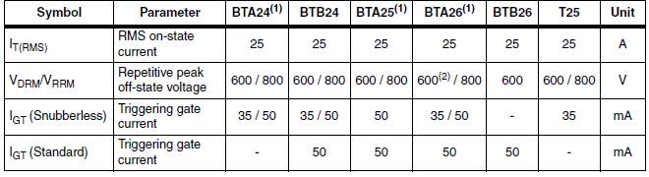

Figure 1: Triac Ratings

## Diac Selection

First we checked the Digikey for the possible components. However, most of the components were obsolete. Then, we look the Direnc.net, we find DB3 DO-35 36 V DIAC. It is appropriate for the circuit since its blocking voltage is similar to our expected voltage. In addition, in the circuit diac does not carry too much current so 2A current rating is useful for the circuit.

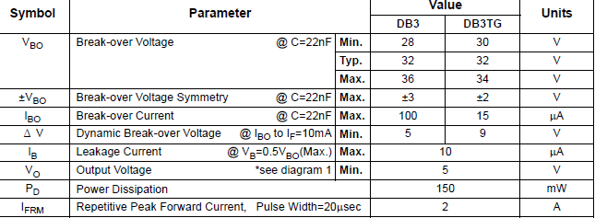

Figure 2: Diac Ratings

## Capacitor Selection

1. In our reference circuit, capacitor value is given as 0.1uf 400 V. We did some changes in reference circuit and we are still in range of capacitor so we can use that values for capacitor. According to this values we choose Ceramic disc capacitor.
2. Figure 3: Capacitor Ratings
3. 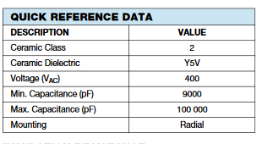

## Resistor Selection

1. We have not specified resistance values. According to starting method, desired performance we are changing our resistance values. While choosing the resistance values, we should be careful about the current that passing through the resistor and power rating of the resistor.

## Additional Components

1. In addition to these main components, we need a circuit board, heatsinks for the semiconductors, maybe a cooling unit. Moreover, we would like to add a feedback unit. According to feedback, we need additional materials.

Thermal Calculations